Title in sentence case: All text in the paper should be in sentence case, except authors name and affiliations (Times new roman: 16)
Author Full Name ¹, Author Full Name ², Author Full Name ³, Author Full Name ⁴
¹ Department, University, City, Country Name
² Department, University, City, Country Name
³ Department, University, City, Country Name
⁴ Department, University, City, Country Name



Article Info:
Received 00 January 2026
Revised 00 February 2026
Accepted 00 March 2026
Published 00 March 2026

Corresponding Author:
Author Full Name
E-mail: name@gmail.com

Copyright: © 2026 by the authors. Licensee Deep Science Publisher. This is an open-access article published and distributed under the Creative Commons Attribution (CC BY) license (https://creativecommo
ns.org/licenses/by/4.0/).
Abstract
Kindly use Ctrl + Shift + V when pasting your data into this template so that the text is pasted without any formatting from your document. All text in the paper should be in sentence case, except authors’ name and affiliations. The abstract must not exceed 250 words. It should briefly outline the purpose, methods, results, and conclusions. Citations are not to be included in the abstract. The paper must contain the main sections: Introduction, Methodology, Results and Discussion, Conclusion, and References, with optional subsections as needed. The entire paper should be prepared in Times New Roman. Font sizes and styles must follow the formatting guidelines provided in the template and as specified in Table 1. References must be cited using numbers in square brackets (e.g., [1]. or [1,5]. or [6-7,9].). The reference list must be formatted according to the Vancouver style. Authors are advised to use the Cite option available in Google Scholar for each paper to ensure accurate formatting. All references cited within the manuscript must be included in the reference list at the end of the document.

Keywords: Keyword in sentence case 1, Keyword 2, Keyword 3, Keyword 4, Keyword 5

- Introduction (This is a section in Times New Roman, 10-point font)
This is body text in Times New Roman, 10-point font with 1.15 line spacing. Please use Ctrl + Shift + V when pasting your data into this manuscript. This will ensure that the text is pasted without any formatting from the source document. The entire paper should be prepared in Times New Roman. Use Word Styles for easy and consistent formatting, which you can find in the toolbar at the top of the document (Refer Fig. 2). The paper must include the mandatory main sections: Introduction, Methodology, Results and Discussion, Conclusion, and References, with optional subsections as needed. Font sizes and styles must follow the formatting guidelines provided in Table 1. References must be cited using numbers in square brackets (e.g., [1]. or [1,5]. or [6-7,9].). The reference list must be formatted according to the Vancouver style. Authors are advised to use the Cite option available in Google Scholar for each paper to ensure accurate formatting. All references cited within the manuscript must be included in the reference list at the end of the document.
- Methodology
This is sub-section (Times New Roman; 10, Italic)
This is body text in Times New Roman, 10-point font with 1.15 line spacing. Use Word Styles for easy and consistent formatting, which you can find in the toolbar at the top of the document (Refer Fig. 2).
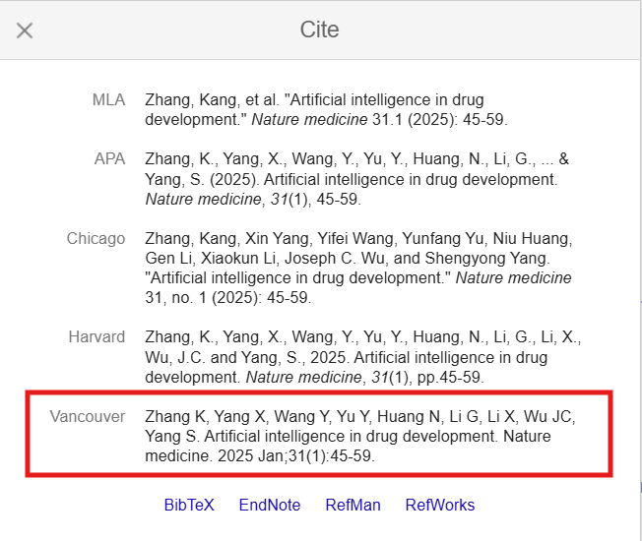
Fig. 1. Vancouver Style on Google Scholar
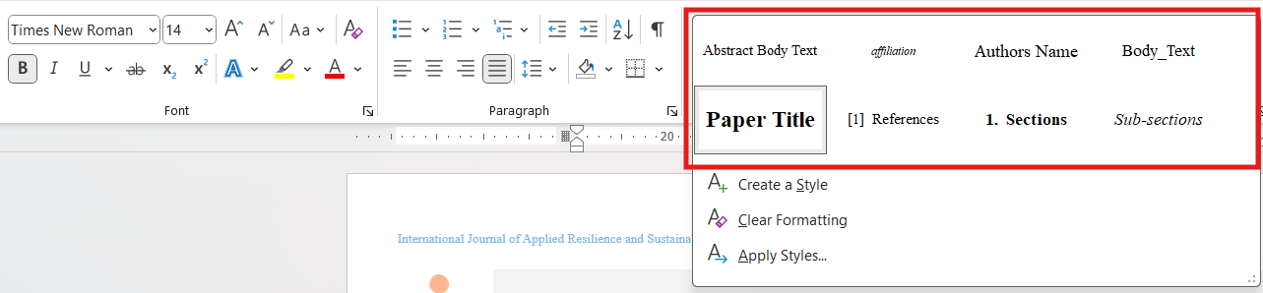
Fig. 2. Use Word styles for easy and consistent formatting
- Results and discussions
This is sub-section (Times New Roman; 10, Italic)
This is body text in Times New Roman, 10-point font with 1.15 line spacing. Use Word Styles for easy and consistent formatting, which you can find in the toolbar at the top of the document (Refer Fig. 2).
Table 3. Font sizes and styles
Item |  | Font Size | Font Style | Sample | Font
Title |  | 16 | Bold | Sample | Entire paper should be prepared in Times New Roman
Author |  | 11 | Regular | Sample | Entire paper should be prepared in Times New Roman
Affiliations |  | 7 | Regular and Italic | Sample | Entire paper should be prepared in Times New Roman
Abstract |  | 9 | Regular | Sample | Entire paper should be prepared in Times New Roman
Keywords |  | 9 | Regular | Sample | Entire paper should be prepared in Times New Roman
Sections |  | 10 | Bold | Sample | Entire paper should be prepared in Times New Roman
Body text |  | 10 | Regular | Sample | Entire paper should be prepared in Times New Roman
Table and Fig. caption |  | 10 | Regular | Sample | Entire paper should be prepared in Times New Roman
Table data |  | 9 | Regular | Sample | Entire paper should be prepared in Times New Roman
References |  | 9 | Regular | Sample | Entire paper should be prepared in Times New Roman

- Conclusions
The
Author Contributions
AFN (Author initials): Conceptualization, study design, analysis, data collection, methodology, software, resources, visualization, writing original draft, writing review and editing, and supervision. AFN: Conceptualization, study design, analysis, data collection, methodology, software, resources, visualization, writing original draft, writing review and editing, and supervision. AFN: Conceptualization, study design, analysis, data collection, methodology, software, resources, visualization, writing original draft, writing review and editing, and supervision.
Conflict of interest
The authors declare no conflicts of interest.
Acknowledgements
Write your acknowledgment here, if any. The name of the funding agency can be mentioned in the acknowledgments section.
References
- Zhang K, Yang X, Wang Y, Yu Y, Huang N, Li G, Li X, Wu JC, Yang S. Artificial intelligence in drug development. Nature medicine. 2025 Jan;31(1):45-59.
- Tu T, Schaekermann M, Palepu A, Saab K, Freyberg J, Tanno R, Wang A, Li B, Amin M, Cheng Y, Vedadi E. Towards conversational diagnostic artificial intelligence. Nature. 2025 Apr 9:1-9.
- Kokina J, Blanchette S, Davenport TH, Pachamanova D. Challenges and opportunities for artificial intelligence in auditing: Evidence from the field. International Journal of Accounting Information Systems. 2025 Dec 1;56:100734.
- Gursoy D, Cai R. Artificial intelligence: an overview of research trends and future directions. International Journal of Contemporary Hospitality Management. 2025 Jan 2;37(1):1-7.
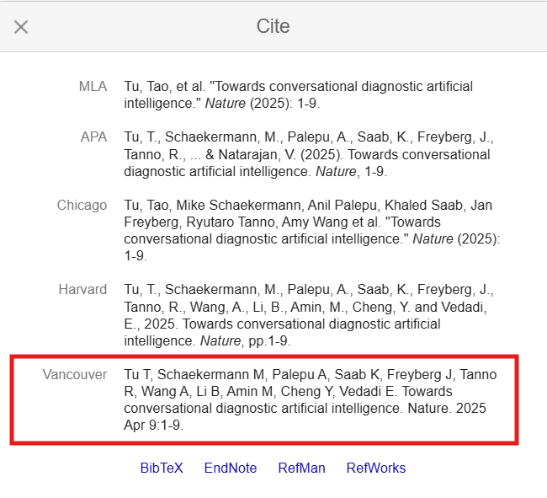
Fig. 3. Vancouver Reference Style on Google Scholar

